SPECIFICATIONS

VERTICAL MEDICAL TECHNICAL COLUMN

**SIMPLE-CARE**

**Principle**

All the workstations will be equipped with a Simple-Care wall technical column manufactured by TLV or an equivalent product:

* Grouping high-voltage and low-voltage current and medical fluid equipment,
* enabling, if necessary, the fastening of a biomedical accessory support vertical stainless steel tube,
* protecting the fluid outlets with a face plate made from ABS/PC with a cover for the AFNOR outlets,
* with RAL 9016 satin white powder epoxy paint.

*(Visual provided as an indication, to understand the description)*

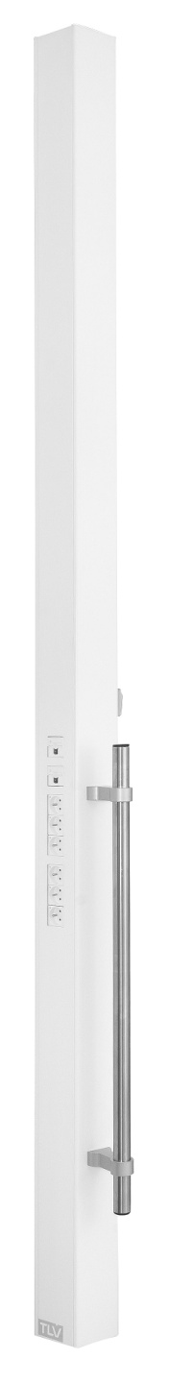**Technical framework**

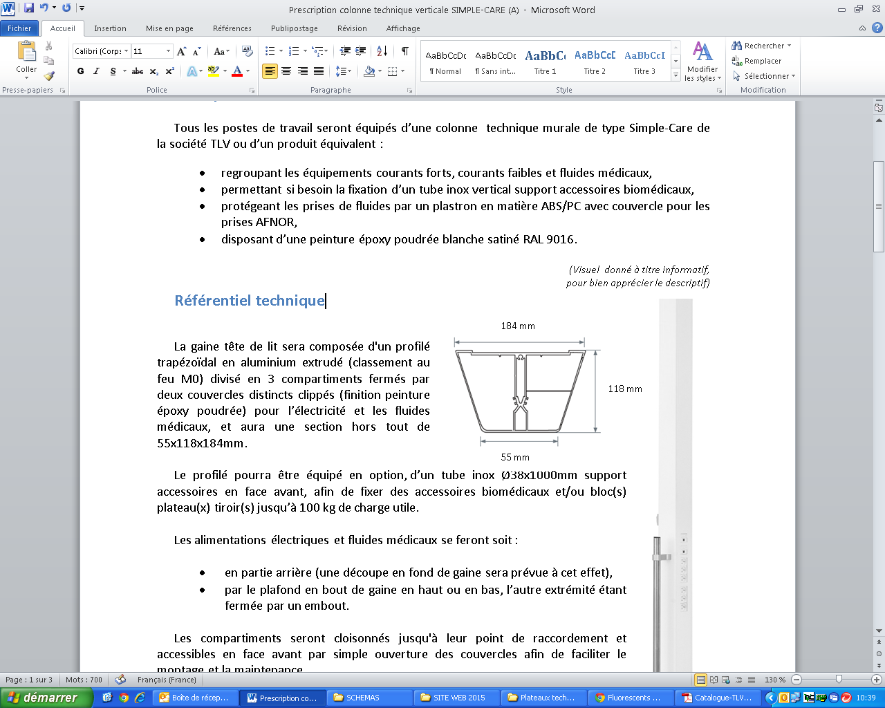

The bed head unit will be composed of an extruded aluminium trapezoid section (M0 fire classification) divided into 3 compartments closed by two separate clipped covers (powder epoxy paint finish) for electricity and medical fluids and will have a an overall section of 55x118x184mm mm (excluding rails).

The section may be equipped, as an option with a Ø38x1000mm accessory support stainless steel tube on the front, to fasten the biomedical accessories and/or drawer tray blocks of up to 100 kg in payload.

The electricity and medical fluid supplies will either be:

* on the back (there will be a cut at the back of the unit for this purpose),
* through the ceiling a the end of the unit on the top or bottom, the other end being closed by a tip.

The compartments will be partitioned up to their connection point and accessible on the front by simply opening the covers to facilitate assembly and maintenance.

Cleaning and disinfection will be facilitated thanks to:

* Smooth surfaces,
* Fluid face plates made from ABS/PC moulded in a rounded shape,
* electrical accessories flush with the cover.

**Installation and Maintenance**

These will be facilitated by**:**

* LV connection terminals with identification of the different networks (PC and lighting) that click in directly (WAGO),
* ELV connection terminals with identification that click in directly (WAGO),
* a cabling diagram placed inside the unit by the connection point,
* a label with electrical safety test results according to NF-EN-11197 which will be placed on the cover inside the unit on the connection terminal,
* a system to automatically earth the covers,
* electrical accessories fastened at the end of the unit (not requiring a clean frame),
* ABS/PC medical fluid face plates joined to cover incorporating the medical fluid compartment ventilation for AFNOR outlets.

**Lighting**

The vertical unit may be equipped as an option:

* a reading spotlight on a FLEX-E LED flex cable,
* a care lamp on an articulated arm,
* an LED night light built in to the low closure end,

**Equipment**

The bed head unit will be composed of electrical and medical gas equipment on each bed including at least:

* 4 PC 10/16A+T on a normal electrical network,
* 2 PC 10/16A+T on a backup electrical network,
* 1 double RJ45 socket,
* 1 pretubed oxygen outlet,
* 1 pretubed medical air outlet,
* 2 pretubed vacuum outlets.

**Normative framework**

The unit is entirely made in a factory and will comply with the following standards, directive and recommendations:

* CE marking in accordance with the medical regulations (2017/745 EU),
* EN ISO 11197: Technical units for medical use,
* EN ISO 7396-1: Medical gas distribution system - Part 1,
* AFE recommendations on lighting healthcare establishments.

The manufacturer undertakes to:

* Provide the tubing test report according to EN ISO 11197 and EN ISO 7396-1,
* Provide the electrical safety test report according to EN ISO 11197 and EN 60601-1,
* Provide proof that the electromagnetic compatibility requirements have been met,
* Provide the valid Medical Device CE certificate issued by a European notified body,
* Provide a CE compliance declaration indicating the device class as well as the name and address of the notified body that has approved the medical device technical file (EN ISO 11197 requirement).
* Provide the ISO 13485 certificates,
* On request, provide the optional lighting studies for ambience, reading and care lighting in the context of installing equipment (if necessary, a test will be performed on the control room).

The equipment will be delivered with the instruction booklet detailing the assembly, installation and maintenance operations (EN ISO 11197 requirement).